**SS TA6**

1. **Tampilan Menu Login**

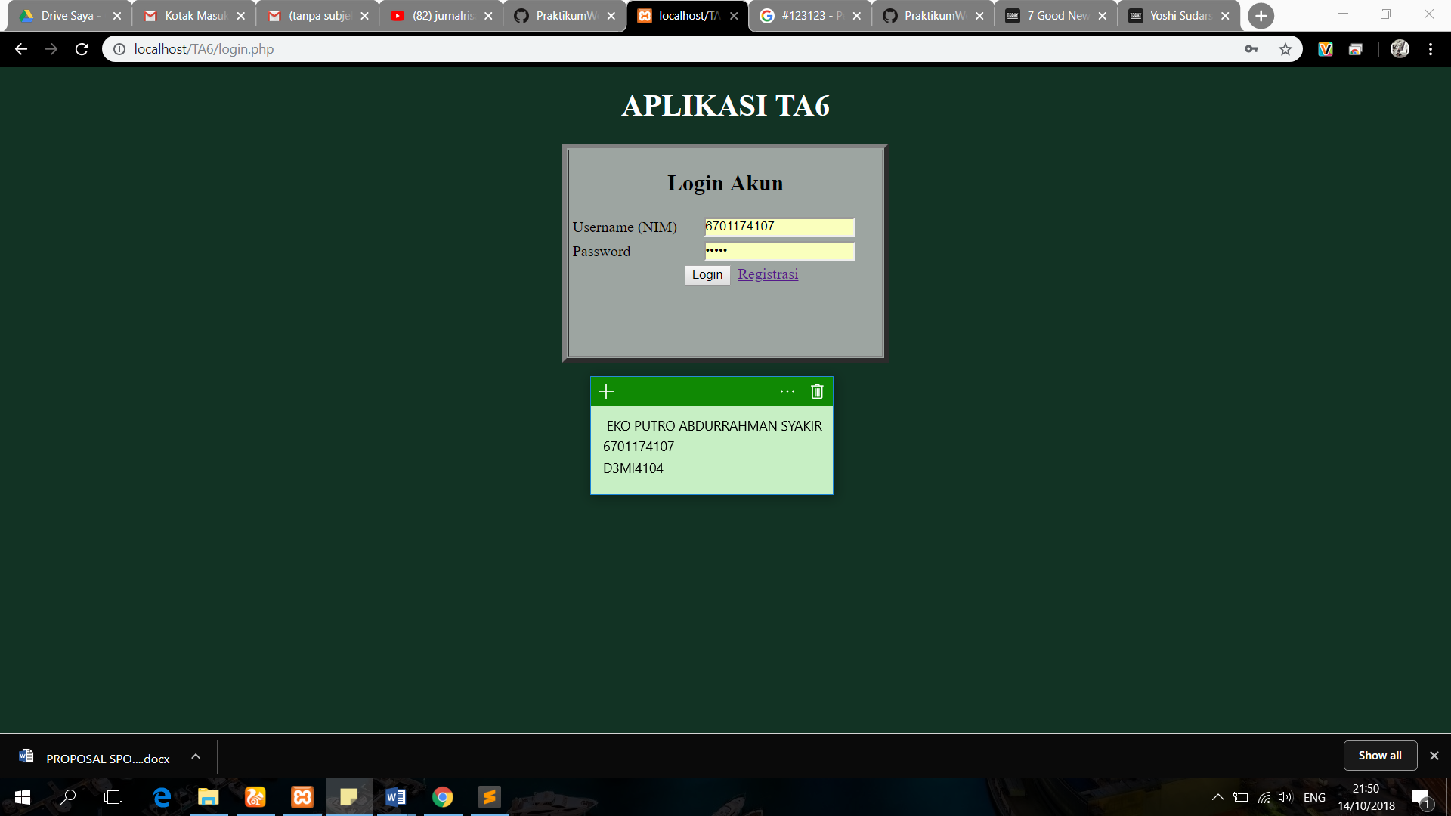

1. **Tampilan Menu Registrasi**

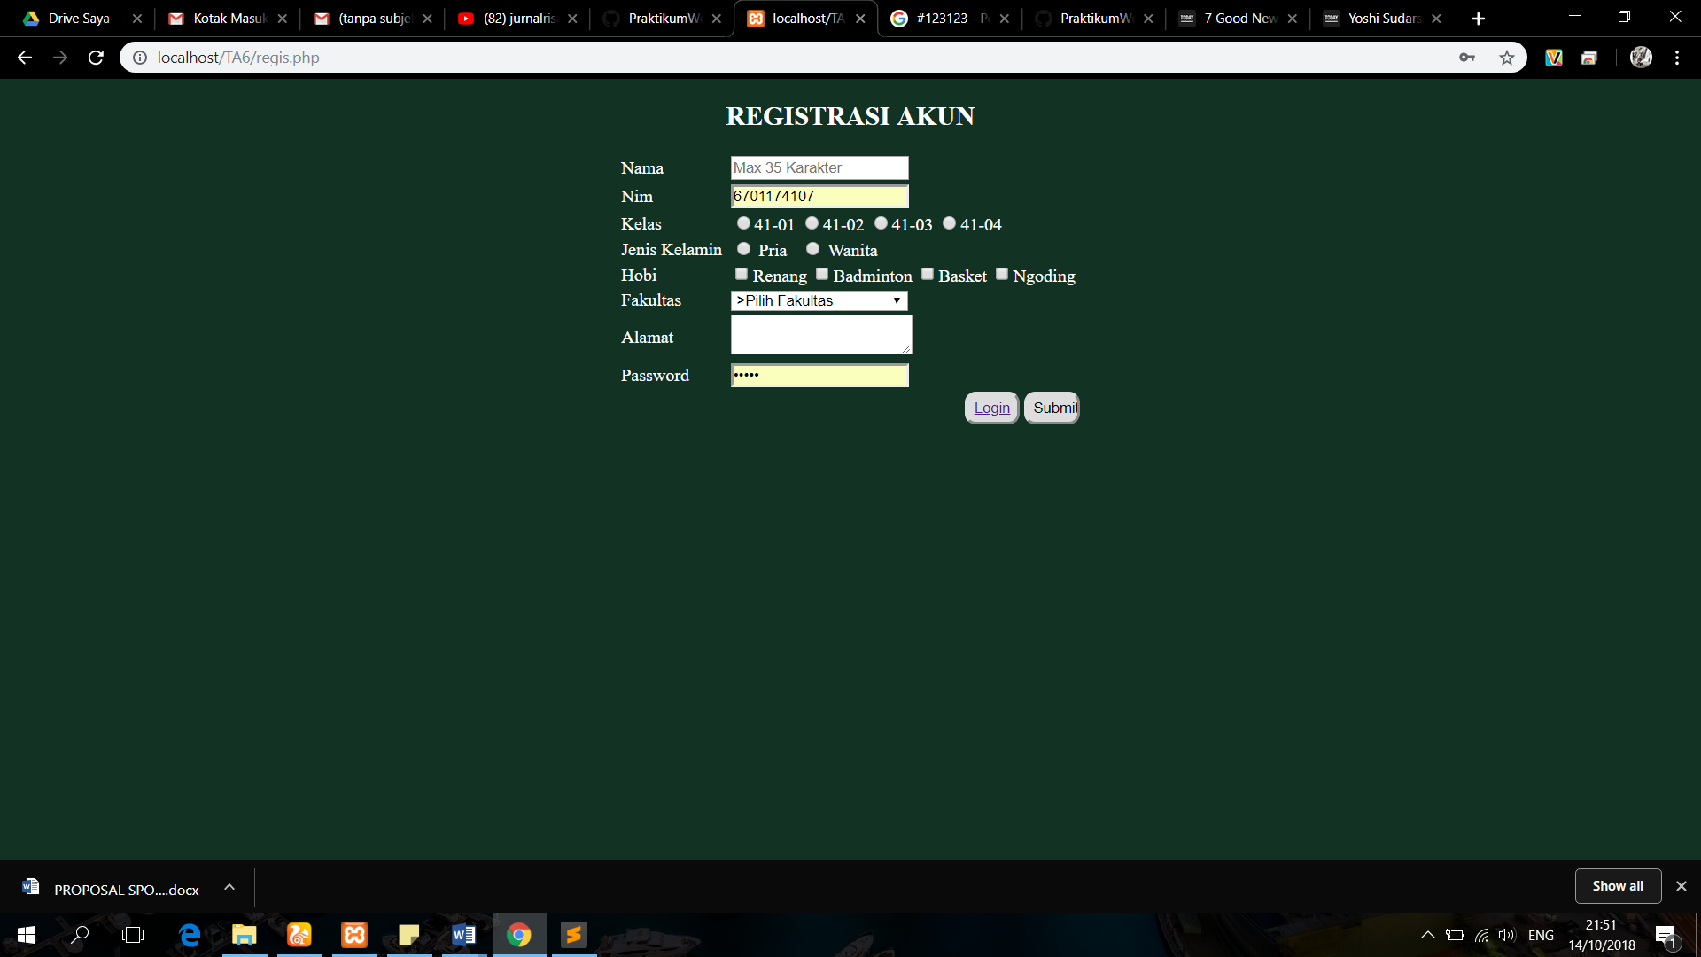

1. **Tampilan Halaman Awal**

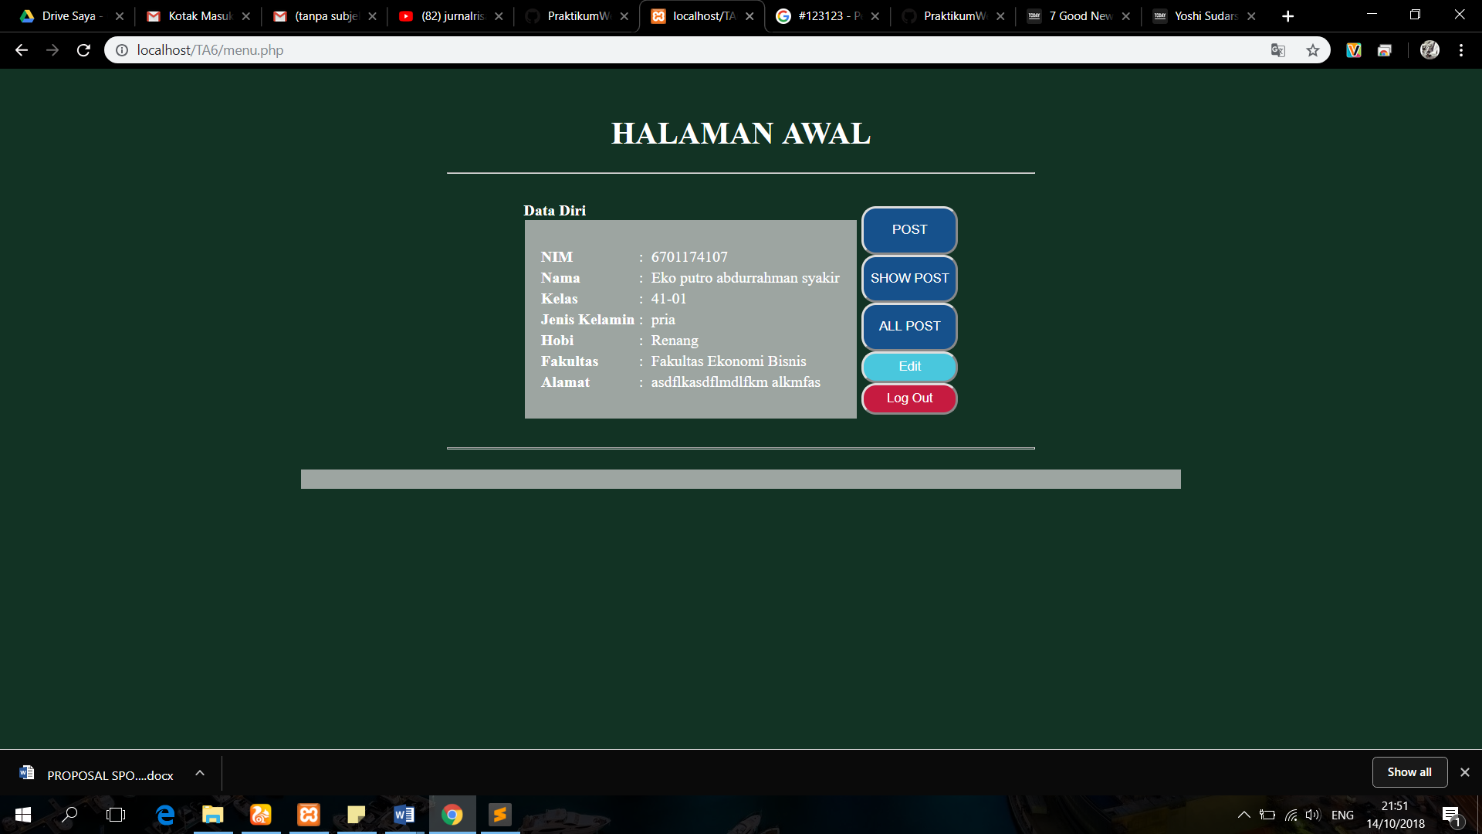

1. **Tampilan Menu POST**

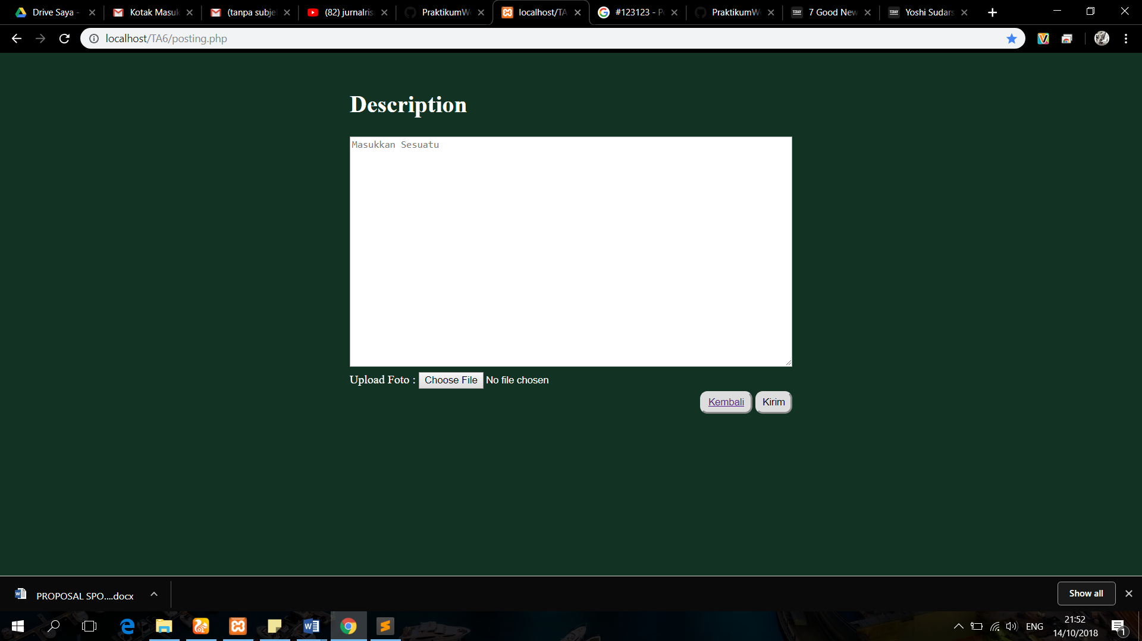

1. **Tampilan Menu Show POST**

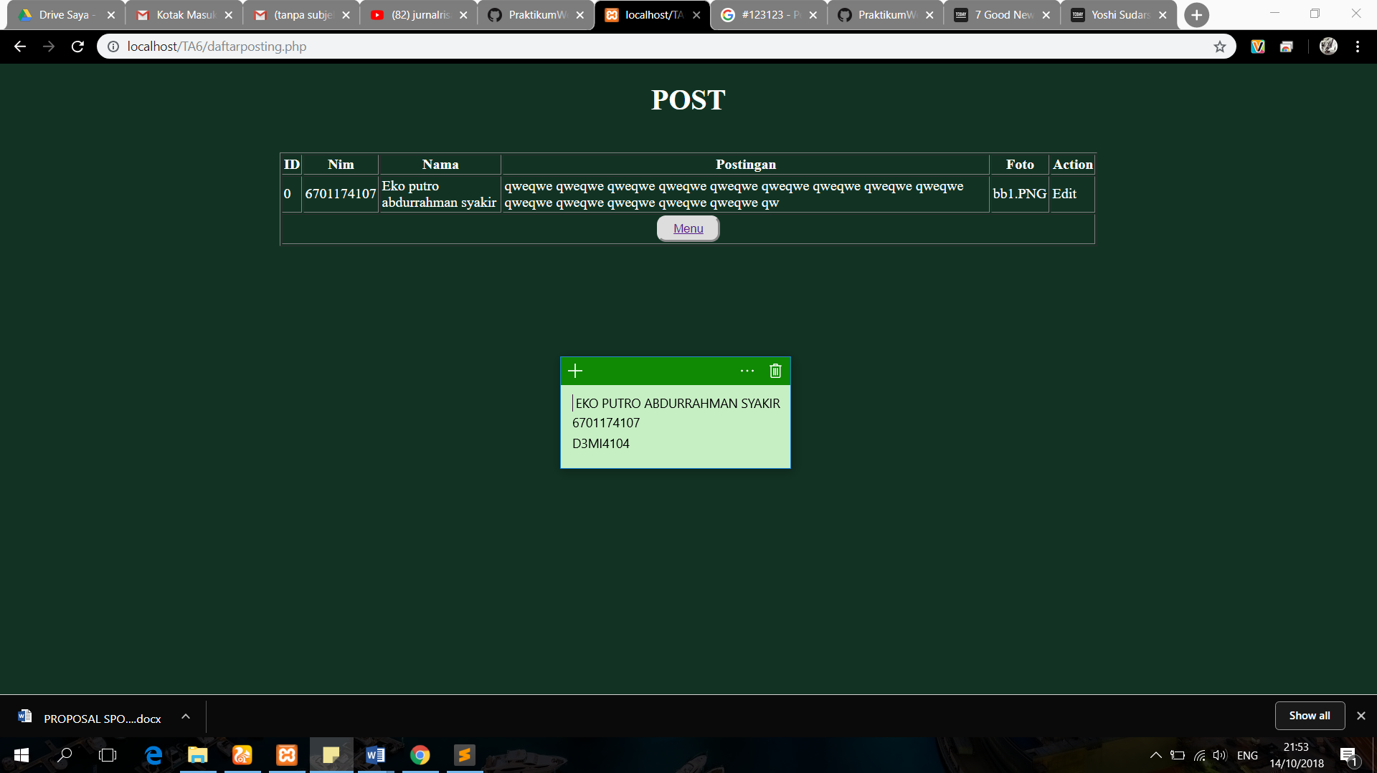

1. **Tampilan Menu ALL POST**

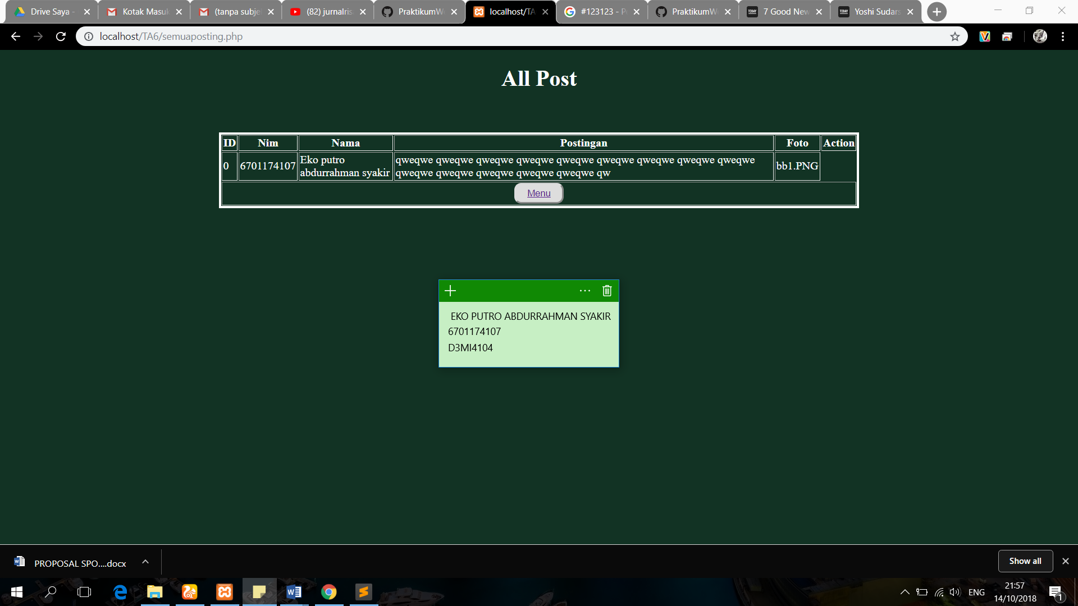

1. **Tampilan Menu Edit**

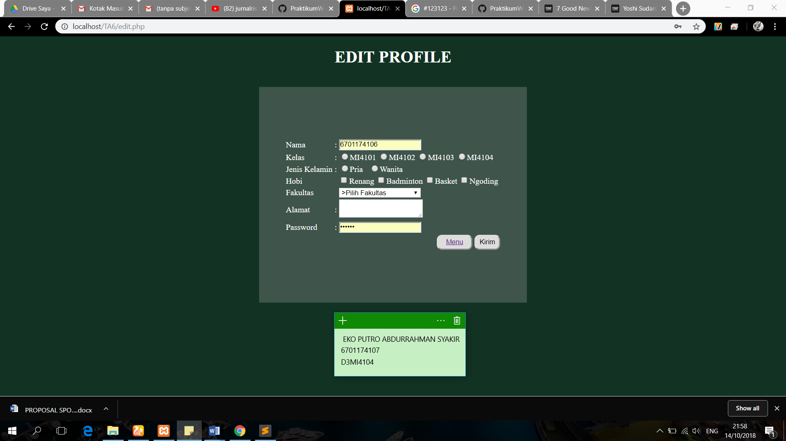

1. **Tampilan Menu Logout**

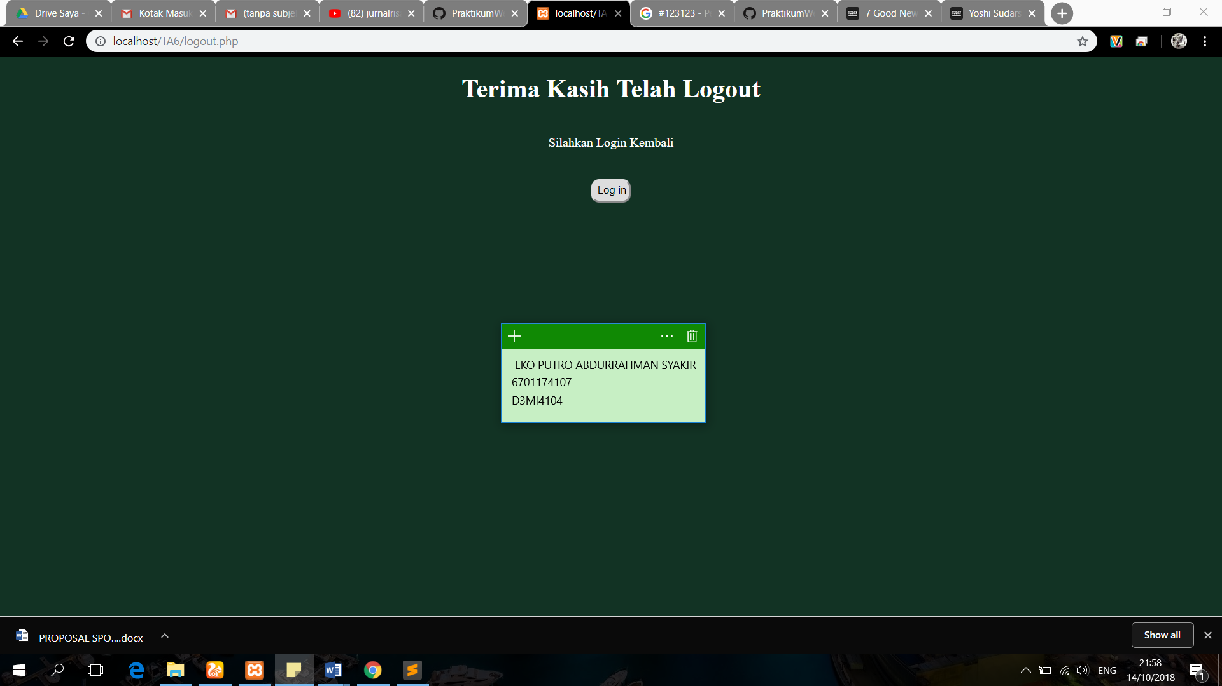

1. **SS Data base kelola user**

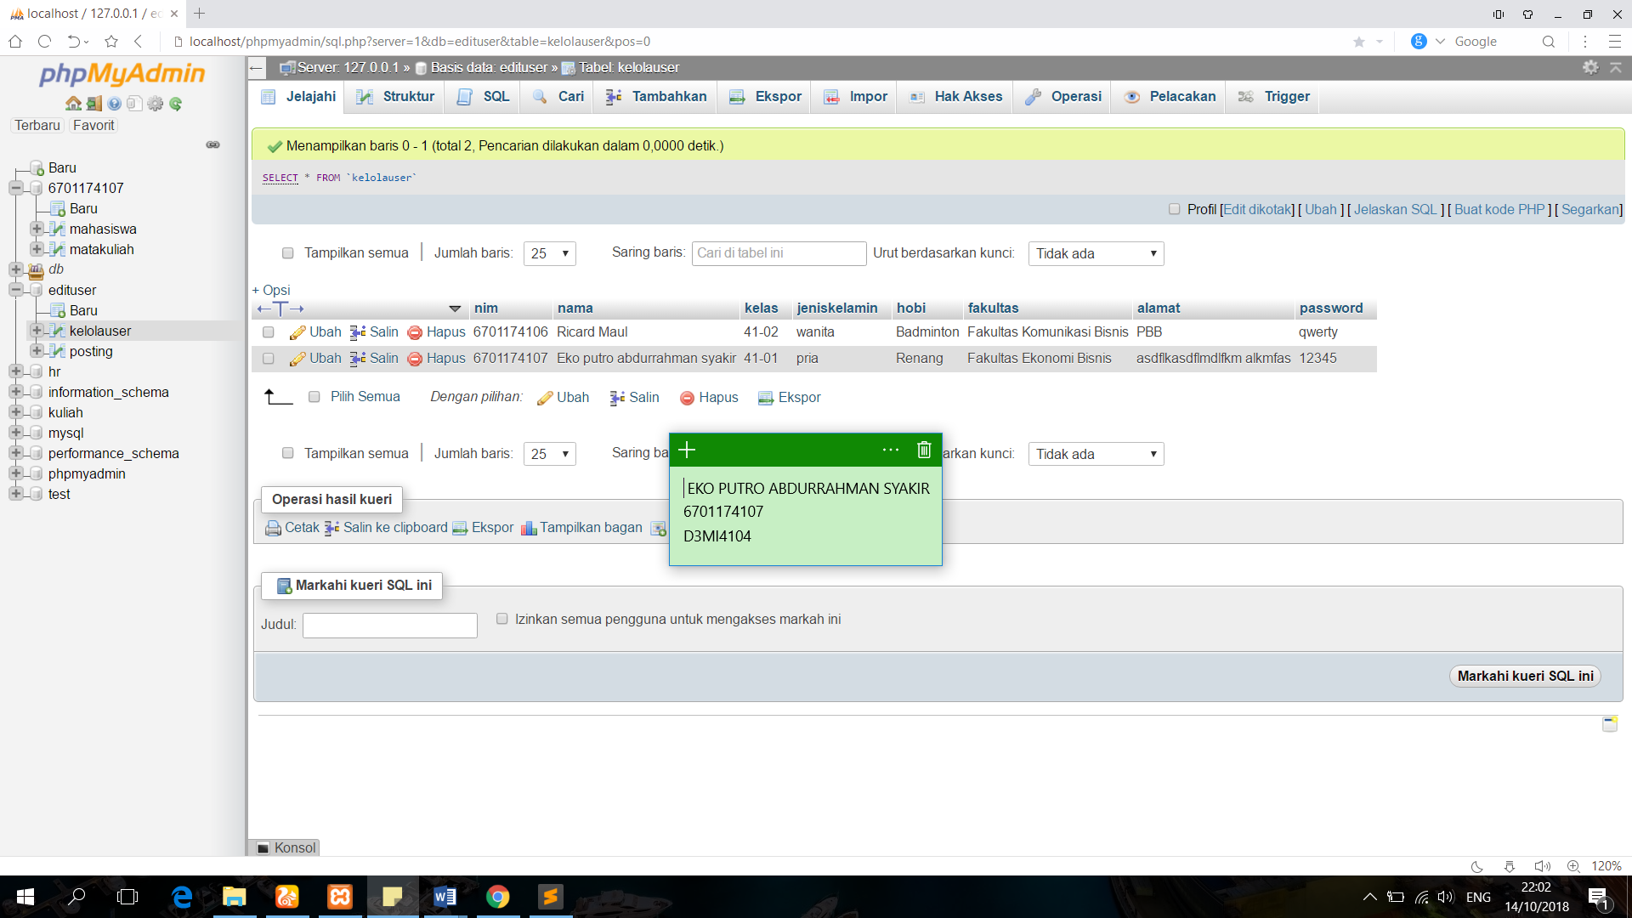

1. **SS Database posting**

